Methodology

- Average battery recipe for EV battery and vehicle components
- Respective HS codes to determine imports and exports as well as the supply chain path followed
- Outlining country-specific % of that data (e.g. In 2023 75% of lithium imports in the US came from China)
- Identifying major companies in this chain and common suppliers which are now moving production to the US from China
- Listing respective ports for the incoming supply by component and country/region.
- Calculating sea distances (in terms of nautical miles) between these ports and the average distance to and from the factory.
- Calculating the carbon footprint with the tons supplied and the distances travelled by these imports (from HS code-specific import export data and the FAF dataset)
- Vehicle cycle: raw materials + processing + manufacturing + assembly + operation + end of life
- Battery cycle: raw materials + transportation + processing + delivery + assembly (joins vehicle cycle at assembly point)
- Emissions = production + materials + transport + end of life

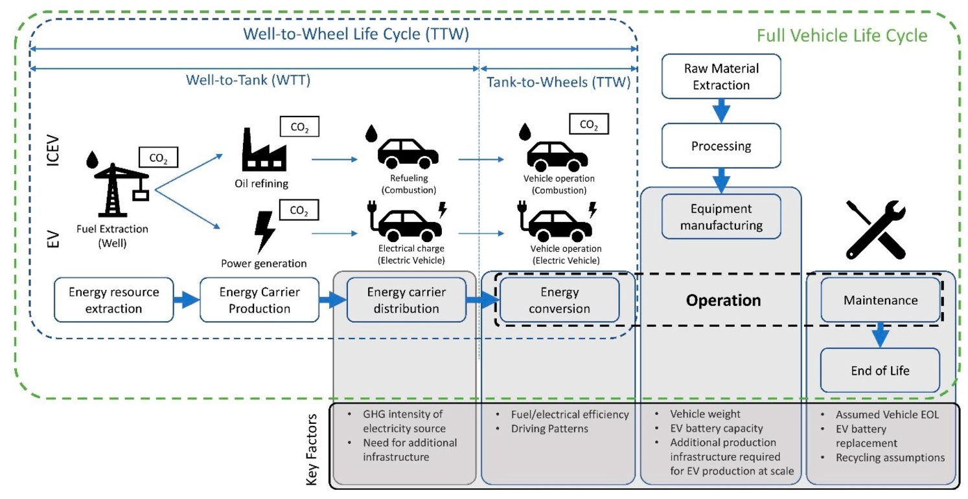

# | Variable | Variable description | Equation | Unit | Calculated for | References
1 | $$d_{ij}$$ | Distance between locations $i,j$ |  | km | mineral | Sea distances org
2 | $$w_{ij}$$ | Weight of mineral transported between locations $i,j$ |  | kg | mineral | Cheng et.al,
4 | $$W_{\%ij}$$ | Weighted % of mineral transported | $$W_{\%ij}=\frac{w_{ij}}{W_{total}}$$ | % | mineral
5 | $$r_{ij}$$ | Weight of mineral 1 kg battery |  | kg | battery | Greet
6 |  |  | $$Contribution=W_{\%ij}×r_{ij}$$ | kg | mineral | Greet
7 | $$e_{α}$$ | Emission Factor for different transport modes $α,β,γ$ | $$E_{ijα}=\left(d_{ij}\right) .\left(Contribution\right) .(e_{α})$$ | Kg CO₂ eq | mineral | Ecoinvent  Greet  IPCC
8 | $$E_{ij}$$ | Emission for mineral between location $i,j$ by transport mode $α,β,γ$ | $$E_{ij}= E_{ijα}+E_{ijβ}+E_{ijγ}$$ | Kg CO₂ eq | mineral
9 | $$E$$ | Total emissions for mineral transportation | $$E=\sum{E_{ij}}$$ | Kg CO₂ eq | mineral
10 | $$T$$ | Trade value | $$T= t_{ij}×contribution$$ | $ / kg | mineral | WIT
11
HS Code:
1 | $$W_{ij}$$ | Weight of commodity between location and US |  | kg | year | World Integrated Trade Solution
2 | $$μ$$ | Conversion factor (contained mineral per item) | $$w_{ij}=W_{ij} . μ$$ | kg | mineral | Cheng et.al,
3 | $$d_{ij}$$ | Distance between location and US |  | km | mineral | Sea distances org
4 | $$w_{\%ij}$$ | Weighted % of mineral transported | $$w_{\%ij}=\frac{w_{ij}}{w_{total}}$$ | % | mineral
5 | $$r_{ij}$$ | Weight of mineral 1 kg battery |  | kg | battery | Greet
6 | $$i$$ | Import reliance |  | % | Mineral | US Mineral Commodity Summaries 2023
7 | $$E_{ij}$$ | Emission for mineral between location $i,j$ by transport mode $α,β,γ$ | $$E_{ij}=r_{ij} . w_{\%ij} .i \{ \left(d_{ijα} . e_{α}\right)+\left(d_{ijβ} . e_{β}\right)+\left(d_{ijγ} . e_{γ}\right) \}$$ | Kg CO₂ eq | mineral
8 | $$E_{us}$$ | Emissions in US domestically | $$E_{us}=r_{ij} . \left(1-i\right) . d_{us} . e_{β}$$ | Kg CO₂ eq | mineral
9 | $$E$$ | Total emissions for mineral transportation | $$E=\sum{E_{ij}} + E_{us}$$ | Kg CO₂ eq | mineral

